**Development of Robot for Inspection of Water Pipeline in a Thermal Power Plant**

**Report**

1. **Objective**

The goal of this project is to design and develop a pipe inspection robot that can significantly improve the efficiency and safety of water pipe inspections. It will limit the need for human operators to enter confined spaces or hazardous environments and can help in rapid diagnosis of the fault. Moreover, the robot's ability to detect small defects and anomalies can help to prevent major problems, improve plant efficiency and reduce maintenance costs.

1. **Introduction**

Thermal power plants are a crucial source of energy worldwide, providing electricity to millions of people. To ensure their safe and efficient operation, regular maintenance and inspection of their components, such as water pipes, are essential. These pipes are designed to supply water from the water source to the power plant. However, inspecting water pipes in thermal power plants can be a challenging task due to their complex and confined structures. This is where the robot can be a valuable tool. A robot can go inside the pipe and inspect areas that are difficult to reach by human operators. In this case, a robot can be used to inspect the water pipes and identify any potential issues such as cracks, corrosion, or blockages. This helps to prevent any accidents, improve the plant's efficiency, and reduce downtime.

In this report, we will discuss the design and development of pipe inspection robots tailored for water pipe inspection. These robots are equipped with sensors and cameras that allow it to inspect the pipes thoroughly, and has specially designed mechanism to work in confined spaces.

1. **­­Working Conditions inside the pipe**

The pipeline length is approximately 17 km and most part of the pipeline is 1.5 m to 3.2 m under the ground making it difficult for humans to access the pipe for inspection. Hence, a robot can be used to inspect the environment inside/ outside the pipe and look for any issues. Also, at this depth wireless connectivity with the robot can be unreliable because signals might be unreachable inside the pipe.

In addition, the pipeline has some amounts of silt and slug present in its lower half. Further, some parts of the pipe are filled with water and are not completely drainable. However, the pipeline has few ARVs and drain valves at regular intervals that can be used for robot deployment and water draining.

Based on the working conditions for the robot, this report discusses four designs of robots. Out of which, three of them are robots that can go inside the pipeline for inspection namely, Land rover type Robot, Magnetic adhesion climbing Robot and Fluid supported Rover Robot. Another type of robot discussed is Drone/ UAVs for aerial supervision.

1. **Land Rover type Robot (Pipe Inspection Robot 1)**

As we know, the pipeline has silt deposition or small mechanical obstacles like welded joints. In such cases, an All-terrain vehicle can be used to travel across the pipeline and collect important data that can be analyzed by experts to detect faults.

In addition, the pipe is buried under the ground, the signal strength is unreliable inside the pipe, and hence, an autonomous robot is required to automatically detect the path and accordingly move in the pipe. The pipe does not have adequate light available. Hence, the robot is designed keeping in mind the challenges inside the pipe.

* 1. **Design**

This is a design of an Autonomous land rover robot. It is capable of traversing across the pipe without any manual interference. To move easily through rough and uneven terrain, it has all-terrain wheels and high torque motors.

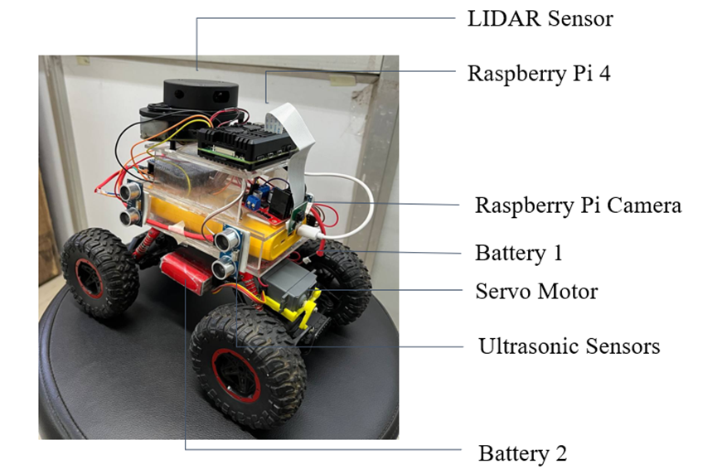

Primary Design of Autonomous Robot

* 1. **Capabilities**
* Robot Maneuvering
  + The robot is capable of autonomous maneuvering through the pipe.
  + Ultrasonic sensors and LIDAR sensors are used to detect the distance of the robot from the pipe walls.
  + The collected data is process and using the PID control the robot self-aligns itself with the pipe.
  + Servomotors are used in the steering for precise steering mechanism.

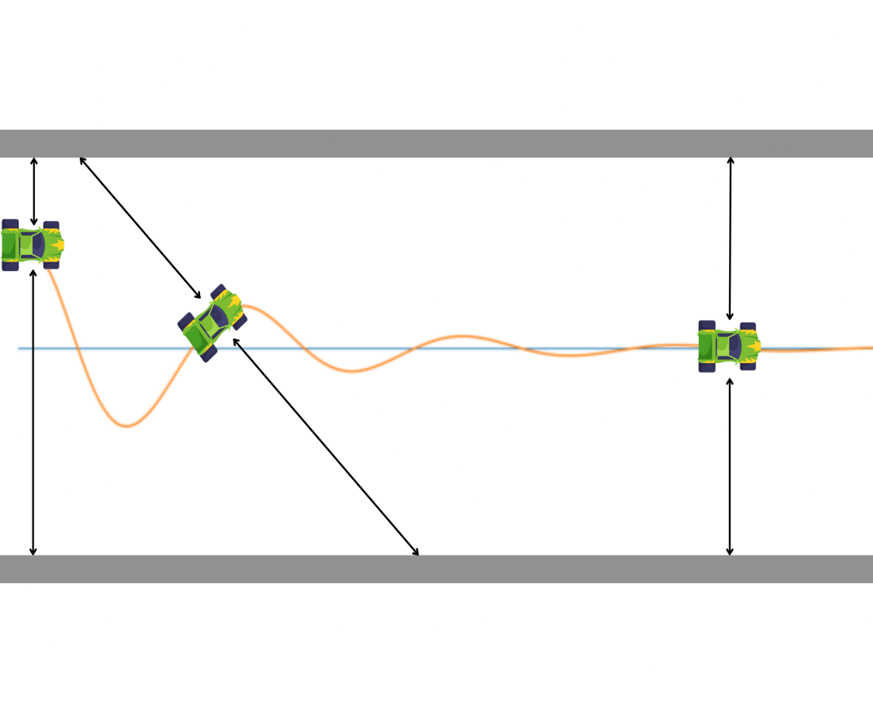

* LIDAR Sensors
  + It helps with 2D mapping of the whole pipeline.
  + It helps the robot with maneuverability.

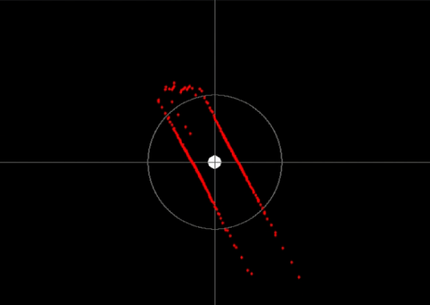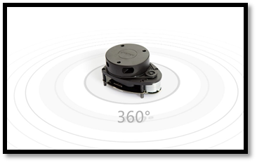

Point cloud diagram using LIDAR

LIDAR sensor mapping in 2D environment

* High quality Camera
  + A High-definition camera with an IR cut filter is equipped able to record clear videos in both day and night light conditions. The camera is equipped with a gimbal to provide stability
  + It helps in object detection and avoidance in case some obstacle comes in the path of movement.
* Run time
  + The robot can run for 1.5-2 hours on a single charge and is able to cover a distance of 1.3-1.7 km.

Further, water-resistant replacements of all the components will ensure its mobility in small amounts of water present in pipe.

* 1. **Simulation:**

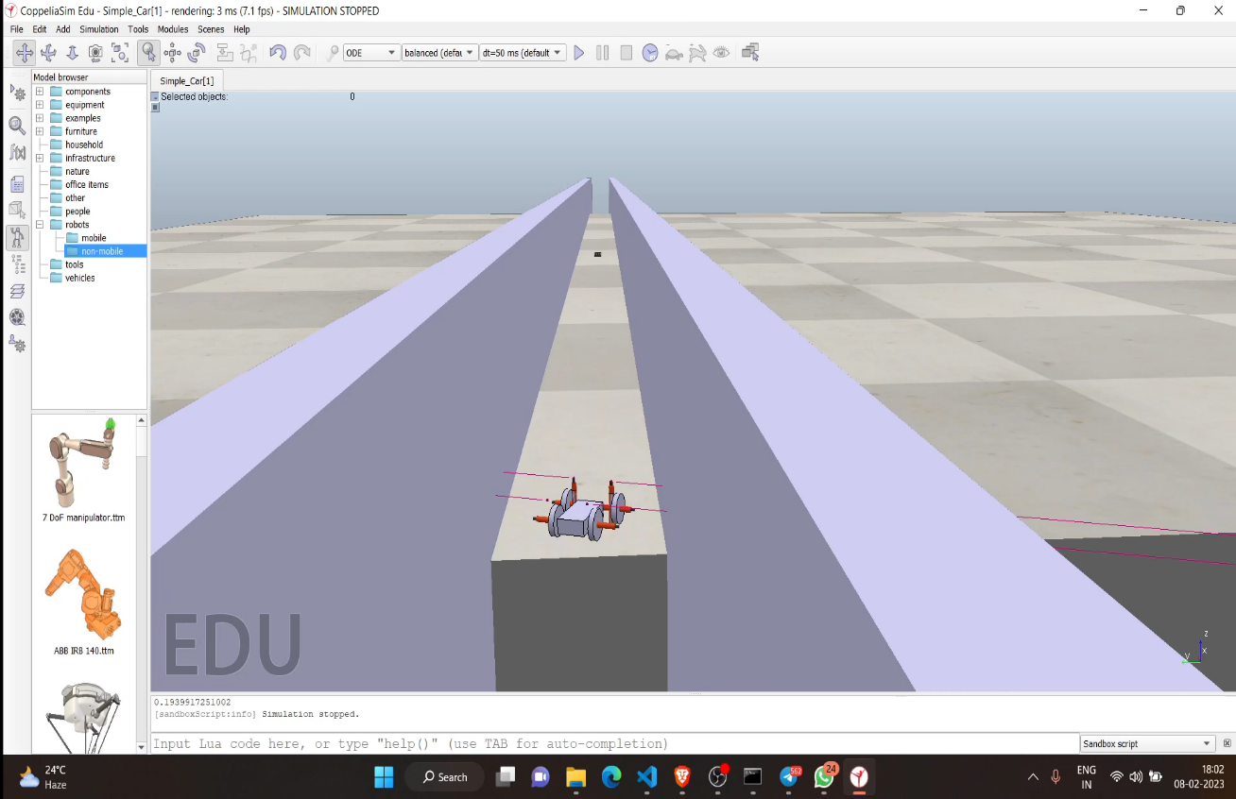

A similar environment was created in Coppelia Sim and the pipe inspection robot was simulated to compare the prototype with the original model of the robot. It helped in estimating the Kp, Kd and Ki values important for PID control in the robot. It also gives a rough estimate of torque and speed of the robot.

* 1. **Limitations in this design:**
* As we know, this robot is capable of maneuvering on surface with uneven terrain/ mud or silt. However, the sections of pipe filled with significant amounts of water can pose a problem for its working.
* Additionally, prolonged usage of a terrain vehicle in water can reduce its lifespan and efficiency.
* So, later in this report are few designs of robots that can tackle this problem and help with the water pipe inspection.
* Alongside with interior inspection robots, the report analysis the use of drones/ UAVs for aerial surveillance of the pipeline and other parts of the thermal power plant.

1. **Magnetic Adhesion climbing Robot (Pipe Inspection Robot 2)**

This type of robot is capable of magnetically sticking and maneuvering on the inner walls of the Mild Steel pipeline for interior inspection. This robot is unaffected by the amount of water filled in the pipe at the time of inspection.

* 1. **Design**

Based on our survey, the pipeline is filled with water and not all parts of the pipeline are drainable. In addition, the water level at different portions of pipe is unknown. In such case, land rover type robots will not be much useful. Hence, a magnetic-climbing robot must be used for inspection purposes. Now, there are various types of magnetic climbing robots based on different types of adhesion used like magnets, vacuum, mechanical grippers etc.

Here, the pipeline is made of ferromagnetic material namely, Mild Steel (Fe410), so magnetic type magnetic climbing robot is the best option in this case. It can stick to the inside surface of the pipe and help in the inspection of the pipe.

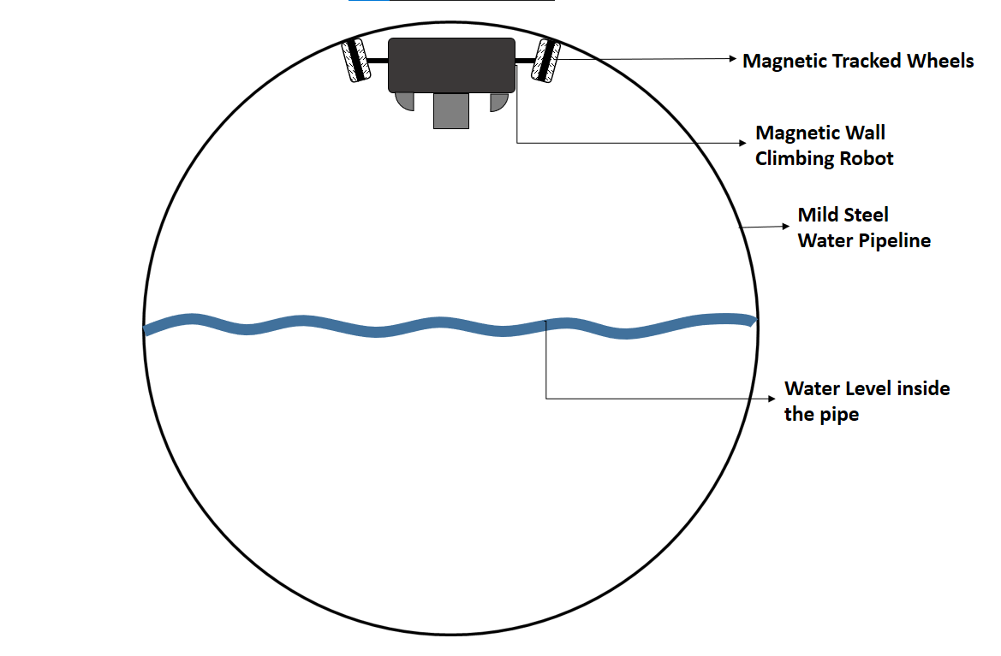

Fig.1 Graphical representation of robot inside the pipeline

* 1. **Crawler type Magnetic Climbing Robot**

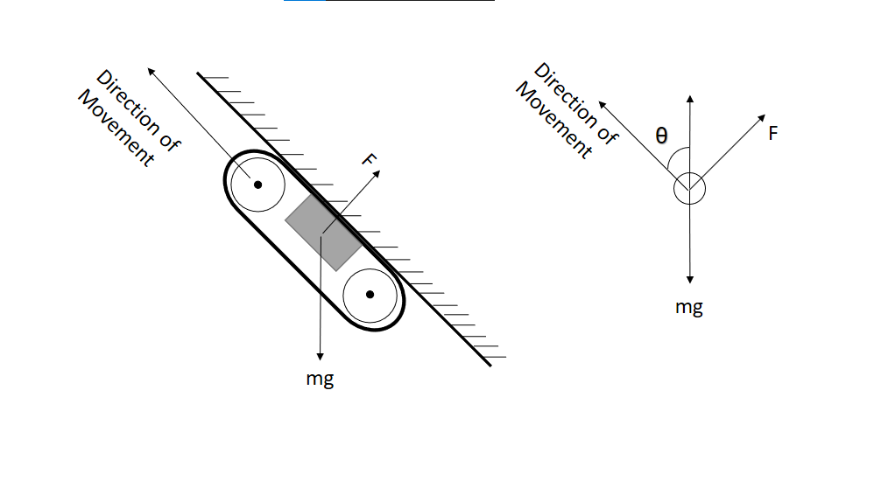

Fig2. Force analysis diagram of robot in adsorption state

Here, F in the diagram is magnetic adsorption force, mg is dead weight of the body and θ is the inclination angle. The block placed inside the robot in the above diagram symbolizes magnet.

When the robot is in stable state,

So, $mg\cos{θ}=\left(F-mg\sin{θ}\right)k$

Where k is the friction coefficient and the static friction coefficient between rubber and metal is about 0.8. If the robot only sticks to the surface, then:

$F= \frac{mg cosθ}{k}+mg sinθ$

Now, for robot to be in motion, the traction force must be more than weight of the robot.

Hence, $F> \frac{mg cosθ}{k}+mg sinθ$

To keep machine in safe state,

$F> \frac{mg cosθ}{k}+\frac{mg sinθ}{k}$ > $\frac{mg cosθ}{k}+mg sinθ$

$F> \frac{mg (cosθ+\sin{θ)}}{k}$

For $θ$ in between 0 and 90, $F> \sqrt{2}\frac{mg }{k}$

For $θ$ in between 0,

$$F> \frac{mg }{k}$$

For $θ$ in between 90, the robot is in state of an inverted horizontal plane and so,

$$F> \frac{mg }{k}>mg$$

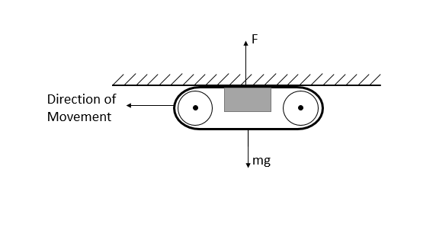

Fig.2 Free body diagram for Crawler Magnetic Climbing Robot

Hence, the adsorption force of the magnets should be at least 1.78 times the weight of robot. Now, based on the adsorption force required by the robot and working clearance of the robot, the dimensions and magnetic properties of the robot can be determined.

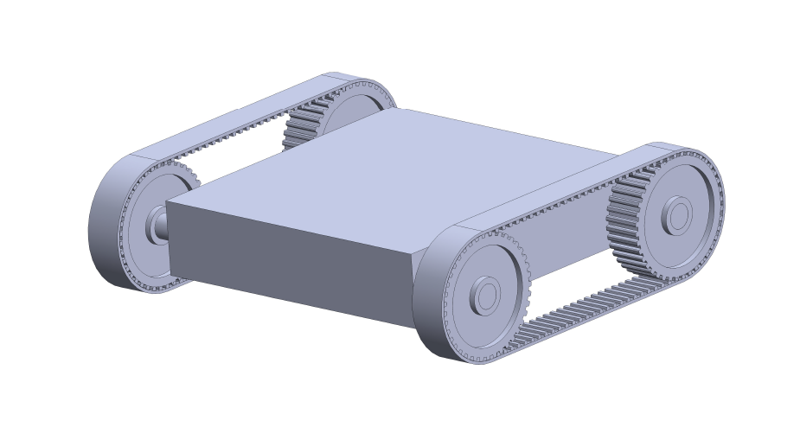

Fig. Primary CAD Design of the robot

* 1. **Sensors used for pipeline inspection:**
* **Cameras**
  + To capture images and video of the inside of the pipe, for analyzing the condition of pipe walls, blockage or any other defects.
* **Infrared Sensors or Temperature Sensors**
  + These sensors help in detecting temperature changes along the length of the pipe, which indicates presence of leaks or other defects.
* **Acoustic sensors**
  + These can be used to detect leaks, blockages, or other anomalies by analyzing the sounds and vibrations produced by water flowing through the pipe.
* **Pressure Sensor**

By adding these sensors to the magnetic tracked climbing robot, company can gather a wide range of data on the condition of their water pipelines, allowing them to identify potential issues early and plan for maintenance and repairs.

* 1. **Benefits of using Magnetic Adhesion climbing robot:**
* **More Traction**
  + Tracked wheeled robots provide with more surface area of contact than normal wheeled robot and hence more traction between pipe and robot.
  + This helps the robot to move easily in rough and uneven terrain.
* **Ease of Control**
  + Magnetic adhesion climbing robots are easy to control than other legged climbing robot or vacuum adhesion climbing robots.
* **More Load carrying capacity**
  + They have high load carrying capacity than those other counter parts.
  + Additionally, these robots have some more advantages of choosing the type and size of magnets.
  + They allow more space for controller and sensors depending on the needs.
* **Safer and Cost saving**
  + It reduces the risk of injury and exposure to hazardous materials to human workers.
  + It saves cost of regular manual inspections of pipe.
* **Versatility**
  + These robots are capable of inspecting pipes of different sizes and shapes and can navigate through tight spaces and obstacles.

1. **Fluid supported Rover type Robot (Pipe Inspection Robot 3)**

Fluid supported rover type robot is a type of pipe inspection robot that can move inside the pipeline. It can be used for inspecting the inside conditions of the pipeline. This type of rover robot moves along the upper surface of the water pipeline while a hollow container floats over the water surface.

* 1. **Design**

Based on our survey, the pipeline is filled with water and not all parts of the pipeline are drainable. In addition, the water level at different portions of pipe is unknown. In such case, we can make use of the fluid/ water present inside the pipe for the benefit of rover type robot. Here, on top of a regular rover, a hollow sealed container is attached and connected using spring like mechanism.

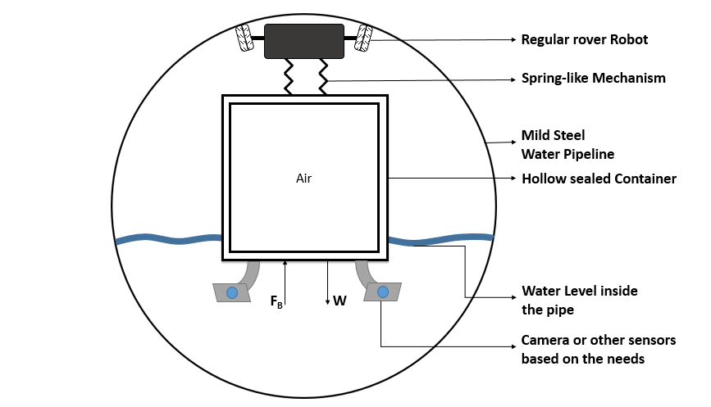This container will be in contact with the surface of water and hence will experience an upward buoyant force, which can be used to oppose the net weight of the system. Here, the net buoyant force on the container should be greater than the net weight of the system. The difference between these values will act as the normal force between the pipe and robot, which will help in the movement of the robot. Using spring mechanism is important because it will make the robot more adaptable for different levels of water present in the pipe and some irregularities in the pipe surface.

Primary Design of Fluid supported rover type Robot

$$F_{B}>W$$

1. **Drones/ UAVs**

An unmanned aerial vehicle/ drone can significantly improve the efficiency and safety of inspection in a thermal power plant. It will limit the need for human operators to enter confined spaces or hazardous environments and can help in rapid diagnosis of the fault. Moreover, the aerial robot would be capable of inspecting pipelines, chimneys, boilers and cooling towers. In addition, it can be used for surveying and monitoring the power plant.

In recent years, drones have emerged as a powerful tool for improving safety, efficiency, and maintenance in various industries, including thermal power plants. Drones equipped with advanced sensors and imaging technology can provide real-time insights into power plant operations, allowing for better decision-making and more effective management of critical assets.

In this report, we will discuss the design, benefits and challenges associated with the use of drones in thermal power plant. It includes the ways in which drones can be used for inspecting pipelines, high structures, monitoring emissions, mapping and surveying in the power plant. The report will also evaluate the economic and technical feasibility of using drones. Ultimately, the goal is to contribute to a safer and more efficient working of the power plant.

* 1. **Capabilities required**
* Thermal Camera
  + To perform infrared thermography to detect cracks, leaks in pipelines and high structures.
  + Thermal imaging can be used to detect moisture and predict where mold may be causing damage. A thermal camera highlights the difference in the regular ground temperature or temperature of the building material and any wet areas. This is because water naturally lowers the temperature of the material that is infiltrated.

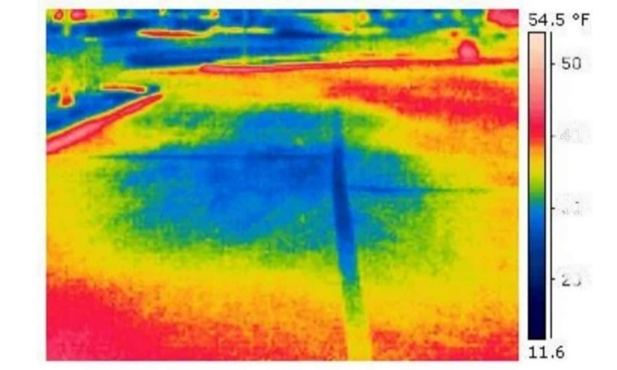

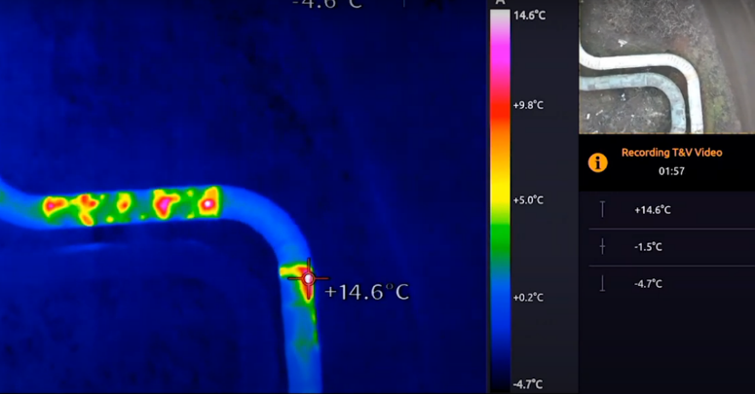

Fig. Thermal Image of Over-ground Water Pipes

Fig. Thermal Image showing water leakage around the pipeline

* High Resolution Camera
  + The drone must be equipped with HD camera capable of capturing high quality images and recording 4K video for inspection and surveillance.
  + AI enabled for scrap management and storage surveillance.
* Robust Design to handle Industrial hazards
* Advanced Navigation
* Wind resistance and Obstacle Avoidance capabilities
* In addition, other environment monitoring sensors as per the requirements.
* Locating the Point of Interest (POI) using the GPS location of defects/ faults.

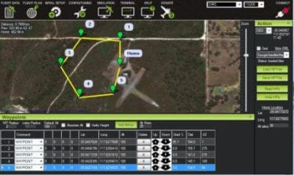

Drone dropping GPS locations for navigation and locating POIs

* 1. **Examples of using Drones in Thermal Power plants:**
* Asset Inspection
  + Many energy infrastructure operators use drones for asset inspection and maintenance work to reduce human visits. The collected data is used to create and update documentation of asset’s technical conditions.
  + Here, drones can be used for inspecting assets like pipelines, boilers, cooling towers, chimneys etc.

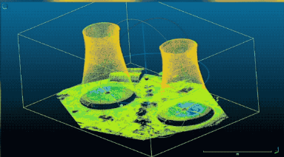

Point cloud representation of Cooling towers in 3D

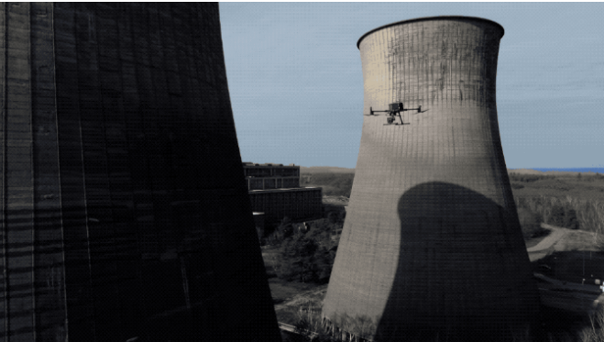

LIDAR enabled drone surveying the Cooling towers

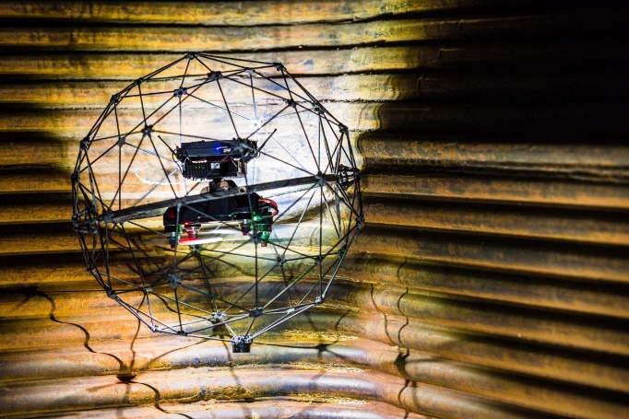

Flyability's Elios 2 during indoor inspection of assets

* Construction
  + Provides a bird eye view for remote inspection of sites for construction planning and works.
  + Additionally, ensure no unauthorized construction is performed near pipeline (outside power plant premises) that can damage the pipeline.
* Maintenance management
  + Operators regularly deploy drones for aerial inspection of facility and accordingly schedule maintenance trips and repair works.

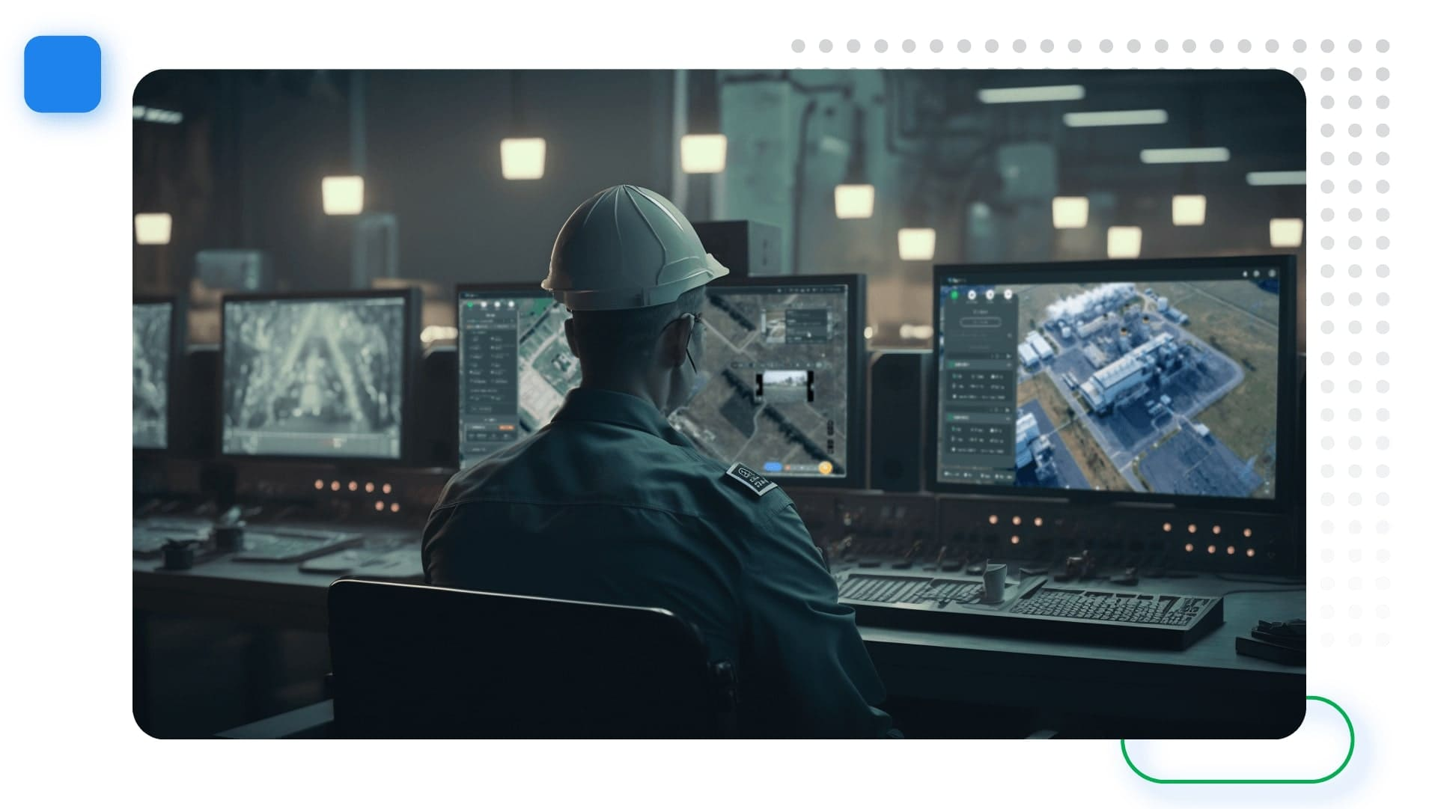

Remote maintenance of power plant using Drones

* Smokestack Inspection
  + Used for inspecting smokestack/ chimneys for regular maintenance and repairs.
  + Using precise detection technology, some companies use drones to assess smoke emissions and potential leaks from power units.

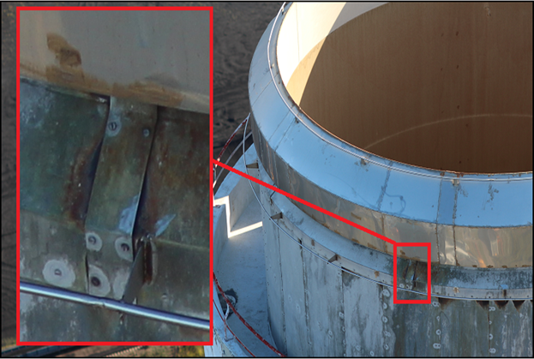

Drone Captured image of smokestack/ chimney showing cracks

* Coal stockpile volume calculation and Scrap management
  + AI enabled cameras help in calculating the coal storage and helps with inventory management in the power plant. In addition, it can be used for scrapyard management.
  + It is used at mining sites for accurate volume calculation of extracted earth. Similarly, it can be used for coal stock calculation.

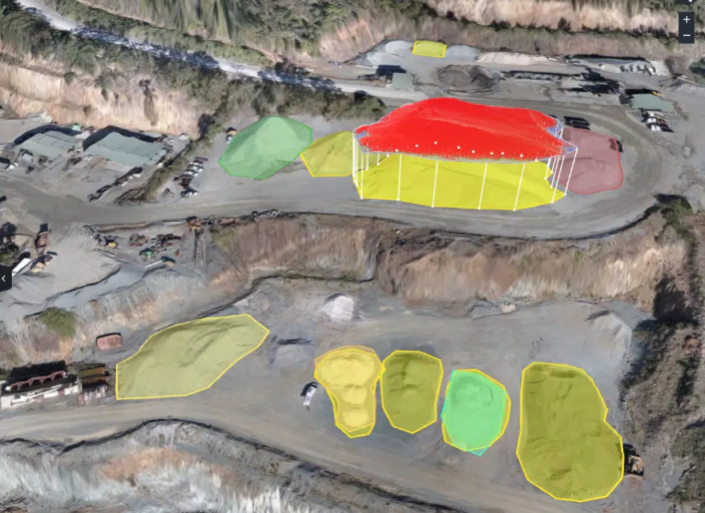

Drone used for Mine surveying and stockpile estimation

* Security and Surveillance
  + Drones are used for security and aerial surveillance of the power plant.
  1. **Additional benefits of using Drones:**
* Provides aerial surveillance for hazardous/ unreachable areas.
* Conditions inside the pipeline or other assets does not affect the performance of the drone.
* Lesser down time.
* Reducing inspection time.
* Cheaper than manual inspection.
* Inspection without plant shutting down.
  1. **Choosing the right drone:**
     1. **Small drones with good camera:**
* DJI MINI 2
  + Price: Rs. 80,000
  + 4k video, 30 min
  + Without thermal camera
  + Buy: shorturl.at/tx034
  + [**https://www.dji.com/mini-2?site=brandsite&from=landing_page**](https://www.dji.com/mini-2?site=brandsite&from=landing_page)

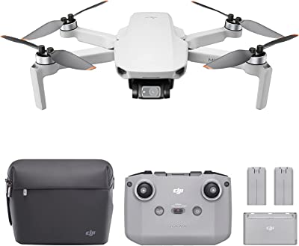

* DJI MINI 3 Pro without thermal camera
  + Price: Rs. 1,00,000
  + Without thermal camera
  + 4k video, 30 min
  + [**https://www.dji.com/mini-3-pro?site=brandsite&from=landing_page**](https://www.dji.com/mini-3-pro?site=brandsite&from=landing_page)

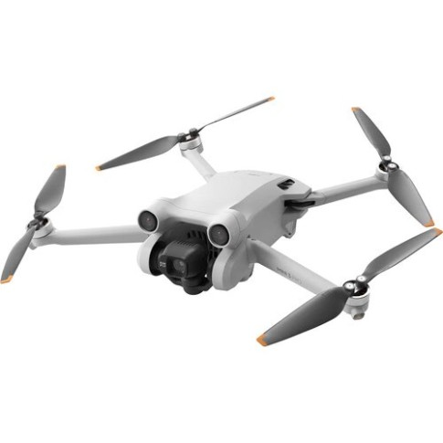

* Garuda Drone
  + Price: Rs. 15,000
  + 1080p video, 30 min fly time
  + Without thermal camera
  + No wind resistance
  + Buy: shorturl.at/txGQ9

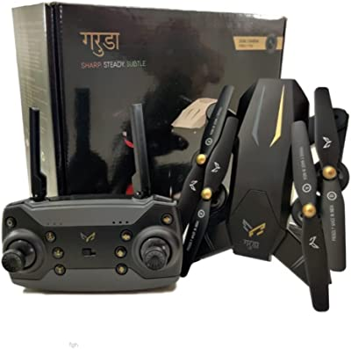

* DJI Mavic Mini
  + Price: Rs. 70,000
  + 2.7k video, 30 min fly time
  + Without thermal camera
  + [**https://www.dji.com/mavic-mini?site=brandsite&from=landing_page**](https://www.dji.com/mavic-mini?site=brandsite&from=landing_page)
  + Buy: shorturl.at/aopyG
    1. **Some best drones for inspection at power plants:**
* DJI Matrice 300 RTK
  + <https://www.dji.com/matrice-300?site=brandsite&from=insite_search>

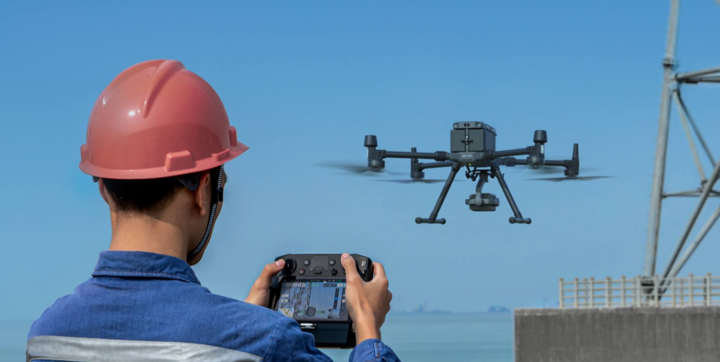

* FLYABILITY ELIOS 2
  + <https://www.flyability.com/elios-2>

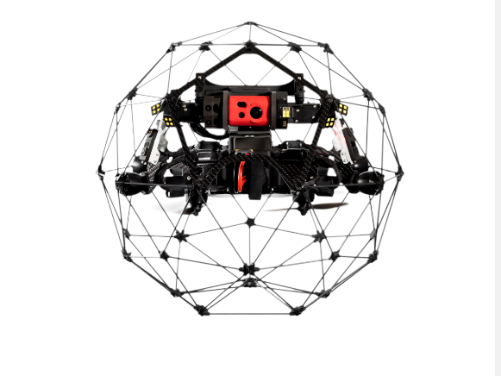

* Parrot ANAFI Ai
  + <https://www.parrot.com/en/drones/anafi>

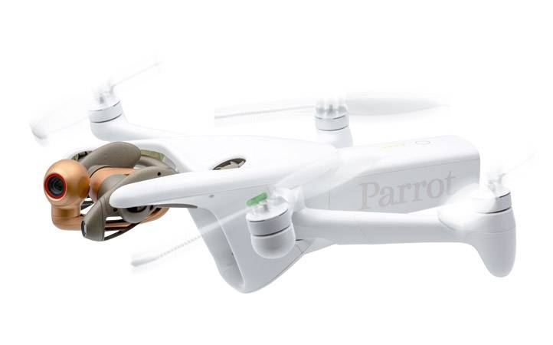

* + 1. **Some Aerial Inspection Companies:**
  + **Garuda Aerospace**
  + **IG Drones**
    - [**https://igdrones.com/**](https://igdrones.com/)
  1. **Some limitations of using drones:**
* Underground Water Inspection using Thermal cameras
  + Pipeline inspection during monsoons in already damp soil can be a challenge for thermal cameras.
  + Leaking water canals near the pipeline can affect the inspection results.
  + Trees and wild plants might have grown just above the underground water pipeline and that can affect the camera results.
  + The underground pipeline is laid near the fields, and irrigating the fields might give false results of water leakage.
* 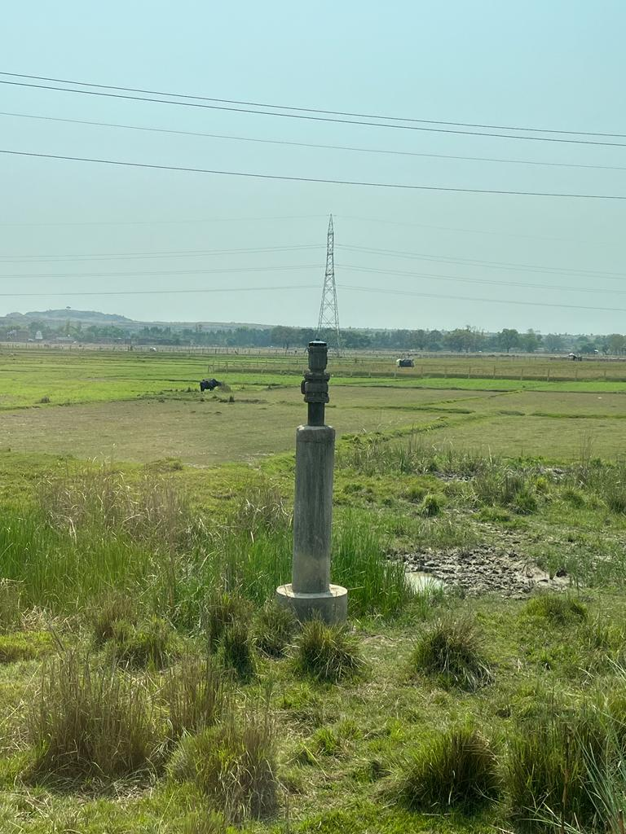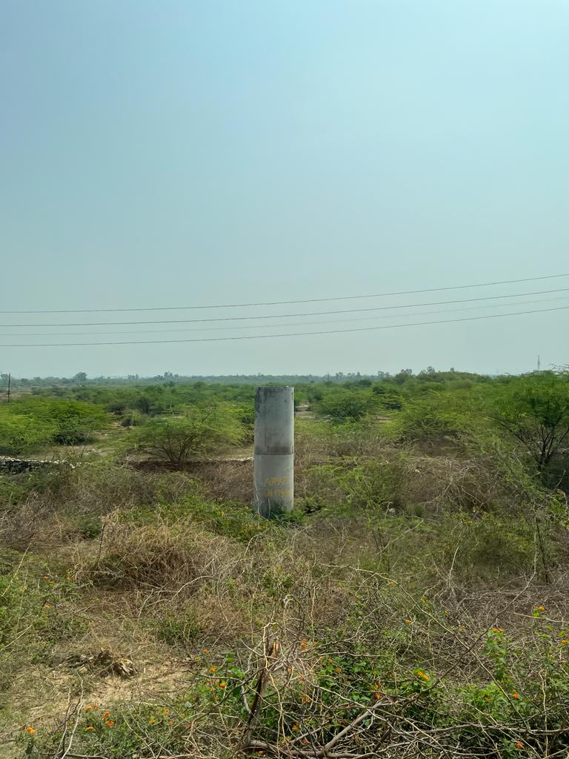Short battery life.

ARV and pipeline very close to the fields

Air Release Valve (ARV) and surrounding pipe area covered with wild plants and trees

**NOTE:** Must follow all DGCA guidelines for operating drones and the driver must hold a license to fly the drone.

1. **References:**

* Land Rover type Robot
  + Li, Hui & Li, Ruiqin & Zhang, Jianwei & Zhang, Pengyu. (2020). Development of a Pipeline Inspection Robot for the Standard Oil Pipeline of China National Petroleum Corporation. Applied Sciences. 10. 2853. 10.3390/app10082853.
  + <https://www.deeptrekker.com/resources/introducing-the-dt340-pipe-crawler>
  + <https://www.deeptrekker.com/resources/deep-trekker-pipe-crawler-faq>
  + <https://litetrax.com/wheels-vs-tracks-advantages-disadvantages/>
  + <https://robu.in/?s=caterpillar+wheels+&product_cat=0&post_type=product>
  + <https://dronebotworkshop.com/getting-started-with-lidar/>
  + <https://core-electronics.com.au/guides/object-identify-raspberry-pi/>
  + Some Youtube videos
    - <https://www.youtube.com/watch?v=-BObt8inVs8>
    - <https://www.youtube.com/watch?v=VhbFbxyOI1k&t=2113s>
* Magnetic Adhesion climbing Robot
  + Zhu, L., & Zheng, X. (2022, December). Design of a Curved Surface Adaptive Permanent Magnet Wall Climbing Robot. In Journal of Physics: Conference Series (Vol. 2405, No. 1, p. 012028). IOP Publishing.
  + Shen, W., Gu, J., & Shen, Y. (2005, July). Permanent magnetic system design for the wall-climbing robot. In IEEE International Conference Mechatronics and Automation, 2005 (Vol. 4, pp. 2078-2083). IEEE.
  + Savall, J., Avello, A., & Briones, L. (1999, May). Two compact robots for remote inspection of hazardous areas in nuclear power plants. In Proceedings 1999 IEEE International Conference on Robotics and Automation (Cat. No. 99CH36288C) (Vol. 3, pp. 1993-1998). IEEE.
  + Shen, W., Gu, J., & Shen, Y. (2005, July). Proposed wall climbing robot with permanent magnetic tracks for inspecting oil tanks. In IEEE International Conference Mechatronics and Automation, 2005 (Vol. 4, pp. 2072-2077). IEEE.
  + Syrykh, N. V., & Chashchukhin, V. G. (2019). Wall-climbing robots with permanent-magnet contact devices: Design and control concept of the contact devices. Journal of Computer and Systems Sciences International, 58, 818-827.
  + Mahmood, S. K., Bakhy, S. H., & Tawfik, M. A. (2020, November). Magnetic–type Climbing Wheeled Mobile Robot for Engineering Education. In IOP Conference Series: Materials Science and Engineering (Vol. 928, No. 2, p. 022145). IOP Publishing.
  + Hu, J., Han, X., Tao, Y., & Feng, S. (2022). A magnetic crawler wall-climbing robot with capacity of high payload on the convex surface. Robotics and Autonomous Systems, 148, 103907.
  + S. Wu, G. Zheng, T. Liu and B. Wang, "A magnetic wall climbing robot with non-contactable and adjustable adhesion mechanism," 2017 IEEE International Conference on Real-time Computing and Robotics (RCAR), Okinawa, Japan, 2017, pp. 427-430, doi: 10.1109/RCAR.2017.8311899.
* Drone/ UAVs
  + YouTube. (2020). YouTube. Retrieved April 6, 2023, from <https://www.youtube.com/watch?v=HO6H67Ew-K0&amp;t=1s>.
  + By. (2023, March 25). Use of infrared to detect underground and concrete water leaks. Thermo Elite Inc. Retrieved April 6, 2023, from <https://thermoelite.ca/use-of-infrared-to-detect-underground-and-concrete-water-leaks/>
  + <https://www.flytnow.com/blog/thermal-power-plant-inspection>
  + <https://forcetechnology.com/en/articles/inspection-using-drone-technology>
  + <https://enterprise-insights.dji.com/user-stories/drone-lidar-inspection-sopreco>
  + <https://www.propelleraero.com/blog/how-stockpile-volume-measurement-works-in-drone-surveying-with-propeller/>
  + <https://www.flyability.com/power-and-utilities>
  + <https://dronebelow.com/2018/08/28/asset-inspection-drones/>
  + <https://www.softdig.com/blog/thermal-imaging-detect-leaks/>
  + <https://www.tdworld.com/grid-innovations/generation-and-renewables/article/21122677/drones-aid-in-remote-monitoring-of-power-plant-assets>
  + <https://percepto.co/thermal-energy/>